Chapter- Living creatures: exploring their characteristics Date:7.11.25 F.M-15
Multiple choice question- 5×1=5 marks
1.A seedling bends toward a window. This is because the:
A) Root absorbs water
B) Shoot shows positive phototropism
C) Seed coat falls off
D) Cotyledon becomes green

2. A student drew a seed diagram but forgot to label the food-storing part. What should be written?
A) Embryo
B) Cotyledon
C) Plumule
D) Radicle

3.Which of the following is not an example of response to stimulus?
a. Watering in our mouth when we see delicious food items.
b. Closing of leaves of Mimosa plant when touched.
c. Shutting of our eyes when an object is suddenly thrown in towards us.
d. A chick hatching out of an egg.

4. In the diagram, the seedling is standing upright even though the seed was originally lying sideways in the soil. What does this show?
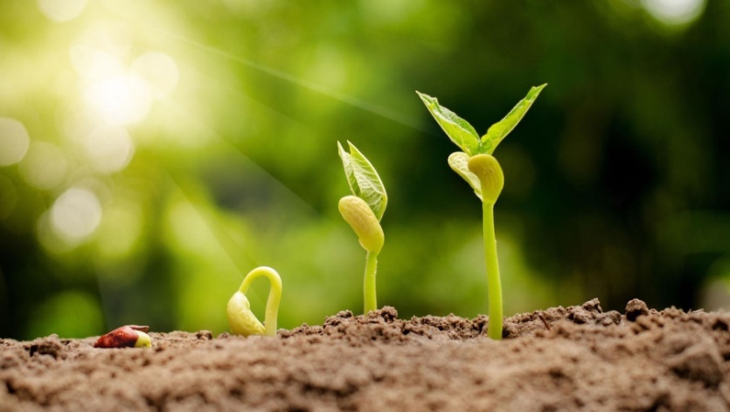
A) Plants grow only in the direction of sunlight.
B) The shoot shows negative geotropism and grows upward.
C) The root stops growing once the leaves appear.
D) The seedling bends because the soil pushes it upward.

5. Assertion (A): The leaves of the Mimosa plant close when we touch them.
Reason (R): The Mimosa plant responds to touch, which is a kind of tropic movement shown by some plants.
(a) Both A and R are true and R is the correct explanation of A
(b) Both A and R are true but R is not the correct explanation of A
(c) A is true but R is false
(d) A is false but R is true

Subjective questions- 10 marks
6. A teacher asked the class, “If insectivorous plants catch insects, does that mean they cannot make food by photosynthesis?”
(a) Can insectivorous plants make their own food by photosynthesis? (1)
(b) If yes, then why do they still trap insects? (1)

7. Riya planted a bean seed in a pot and observed it every day. First the seed swelled and a tiny root came out. After a few days, a small shoot with leaves appeared. Later, the plant grew flowers, and after some time, pods with new seeds developed on the plant.
(a) Arrange the stages of the plant’s life cycle in the correct order based on Riya’s observation with a diagram. (2)
(b) The formation of seed is an important final stage in the life cycle of a plant. Justify the statement. (1)

8. A plant was kept in a room with light entering only from one window. The stem of the plant bent toward Y (window side) and away from X (dark side).
(a) With an appropriate diagram explain which type of movement shown by the shoot. (3)
9. During winter, a gardener noticed that the petals of tulip flowers remained tightly closed in the early morning when the temperature was low. But as the day became warmer, the petals slowly opened by themselves.
(a) What kind of movement is shown by the tulip flowers in this situation? (1)
(b) Why do the flowers stay closed in cold weather and open when the temperature rises? (1)

